**Angular vs React**

In terms of performance, bundle size, and backward compatibility, ***React outperforms Angular***. The component-driven architecture of React allows developers to reuse code components, which tends to save cost and time. It also outperforms Angular due to its rendering optimizations and Virtual DOM implementation

**Comparisons between Angular vs React:**

|  |  |  |
| --- | --- | --- |
| **Parameters** | **Angular** | **React** |
| **Developed By** | Google | Facebook |
| **Release Year** | 2009 | 2013 |
| **Written In** | TypeScript | JavaScript |
| **Technology Type** | Full-fledged MVC framework written in JavaScript | JavaScript library (View in MVC; requires Flux to implement architecture) |
| **Concept** | Brings JavaScript into HTML Works with the **real DOM Client-side rendering** | Brings HTML into JavaScript Works with the **virtual DOM Server-side rendering** |
| **Data Binding** | Two-way data binding | One-way data binding |
| **Language** | JavaScript + HTML | JavaScript + JSX |
| **Learning Curve** | Steep (deep learning , has huge documentation) | **Moderate** (less time , few life cycle method which are self explanatory) |
| **Best Suited For** | Highly active and interactive web apps | Larger apps with recurrent variable data(It solves the problem of **effectively rendering large data sets** in web applications) |
| **App Structure** | Fixes and complicated MVC | Flexible component-based view |
| **Dependency Injection** | Fully supported | Not supported |
| **Performance** | Angular framework is quite huge and little bit behind than react in performance | React has a Virtual DOM due to it's library size is small and it **improves performance** |
| **DOM Type** | Real | Virtual |
| **Scalability** | For data binding, angular uses ngrx, Angular is **easy to scale** | whereas react uses Redux, react is more testable and can also be scalable but not as angular. |
| **Popular Apps** | IBM, PayPal, Freelancer, Upwork | Facebook, Skype, Instagram, Walmart |

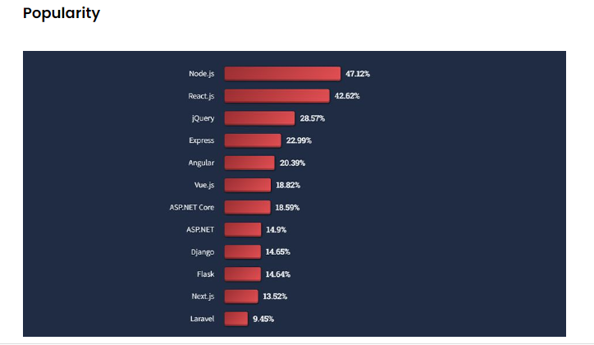

**Reference Links:-**

<https://www.educba.com/angular-vs-react/>

**<https://iot4beginners.com/reactjs-or-angularjs-which-is-best-for-iot/>**